As filed with the Securities and Exchange Commission on May 18, 2026

Registration No. 333-

UNITED STATES

SECURITIES AND EXCHANGE COMMISSION

Washington, D.C. 20549

FORM S-8

REGISTRATION STATEMENT

UNDER

THE SECURITIES ACT OF 1933

BRIGHTSPIRE CAPITAL, INC.

(Exact name of registrant as specified in its charter)

Maryland | 38-4046290
(State or other jurisdiction of | (IRS Employer
incorporation or organization) | Identification Number)
590 Madison Avenue, 33rd Floor | 10022
New York, NY | 10022
(Address of principal executive offices) | (Zip code)

BrightSpire Capital, Inc. 2022 Equity Incentive Plan

(Full title of the Plan)

David A. Palamé

590 Madison Avenue, 33rd Floor

New York, New York 10022

(Name and address of agent for service)

(212) 547-2631

(Telephone number, including area code, of agent for service)

Copies to:

Stuart A. Barr

Amy Blackman

Fried, Frank, Harris, Shriver & Jacobson LLP

801 17th Street, NW

Washington, DC 20006

(202) 639-7000

Indicate by check mark whether the registrant is a large accelerated filer, an accelerated filer, a non-accelerated filer, a smaller reporting company or an emerging growth company. See the definitions of “large accelerated filer,” “accelerated filer,” “smaller reporting company,” and “emerging growth company” in Rule 12b-2 of the Exchange Act.

Large accelerated filer | ☒ | Accelerated filer | ☐
Non-accelerated filer | ☐ | Smaller reporting company | ☐
 |  | Emerging growth company | ☐

If an emerging growth company, indicate by check mark if the registrant has elected not to use the extended transition period for complying with any new or revised financial accounting standards provided pursuant to Section 7(a)(2)(B) of the Securities Act. ☐

EXPLANATORY NOTE

On May 13, 2026, the Class A common stockholders of BrightSpire Capital, Inc., a Maryland corporation (the “Company”), approved the second amendment to the BrightSpire Capital, Inc. 2022 Equity Incentive Plan, as heretofore amended (the “2022 Plan” and such second amendment, the “2022 Plan Amendment”) to increase the total number of shares of Class A common stock of the Company, $0.01 par value per share (the “Common Stock”) issuable under the 2022 Plan by 10,000,000 shares and to clarify and provide a cash-denominated limit on awards to non-employee directors in any calendar year.

Pursuant to General Instruction E of Form S-8, 10,000,000 shares of the Common Stock are hereby registered for issuance, as authorized by the 2022 Plan Amendment. The contents of the Company’s Form S-8 filed on February 1, 2018 (File No. 333-222812) and the Form S-8 filed on May 5, 2022 (File No. 333-264725) are incorporated herein by reference and made a part hereof.

PART I

INFORMATION REQUIRED IN THE SECTION 10(a) PROSPECTUS

The documents containing the information specified in Part I will be sent or given to the persons participating in the 2022 Plan, as specified by Rule 428(b)(1) under the Securities Act of 1933, as amended (the “Securities Act”). In accordance with the instructions to Part I of Form S-8, such documents need not be filed with the Securities and Exchange Commission (the “Commission”) either as part of this registration statement or as prospectuses or prospectus supplements pursuant to Rule 424 promulgated under the Securities Act. These documents and the documents incorporated by reference in this registration statement pursuant to Item 3 of Part II of this registration statement, taken together, constitute a prospectus that meets the requirements of Section 10(a) of the Securities Act.

PART II

INFORMATION REQUIRED IN THE REGISTRATION STATEMENT

Item 3. Incorporation of Documents by Reference.

The following documents, which the Company has previously filed with the Commission, are hereby incorporated by reference into this registration statement:

- The Company’s Annual Report on Form 10-K for the fiscal year ended December 31, 2025, filed on February 18, 2026.

- The Company’s Current Reports on Form 8-K filed on February 23, 2026, March 18, 2026, April 1, 2026 and May 13, 2026;

- The Company’s Quarterly Report on Form 10-Q filed on April 29, 2026; and

1

- The description of the Common Stock contained in its Registration Statement on Form 8-A, filed on January 31, 2018, pursuant to Section 12 of the Securities Exchange Act of 1934, as amended (the “Exchange Act”), and all amendments or reports filed for the purpose of updating such description.

In addition, all documents and reports subsequently filed by the Company pursuant to Sections 13(a), 13(c), 14 and 15(d) of the Exchange Act (excluding any information that is deemed to have been “furnished” and not “filed” with the Commission, including any Item 2.02 or Item 7.01 of any Current Report on Form 8-K), prior to the filing of a post-effective amendment which indicates that all securities offered have been sold or which deregisters all securities remaining unsold, shall be deemed to be incorporated by reference in this registration statement and to be part hereof from the date of filing of such documents or reports. Any statement contained in a document incorporated or deemed to be incorporated by reference herein shall be deemed to be modified or superseded for purposes of this registration statement to the extent that a statement contained herein or in any other subsequently filed document which also is or is deemed to be incorporated by reference herein modifies or supersedes such statement. Any such statement so modified or superseded shall not be deemed, except as so modified or superseded, to constitute a part of this registration statement.

Item 4. Description of Securities.

Not applicable.

Item 5. Interests of Named Experts and Counsel.

Not applicable.

Item 6. Indemnification of Directors and Officers.

Maryland law permits a Maryland corporation to include in its charter a provision eliminating the liability of its directors and officers to the corporation and its stockholders for money damages except for liability resulting from: (i) actual receipt of an improper benefit or profit in money, property or services; or (ii) active and deliberate dishonesty that is established by a final judgment and is material to the cause of action. The Company’s charter contains such a provision that eliminates directors’ and officers’ liability to the maximum extent permitted by Maryland law.

The Company’s charter and bylaws obligate it, to the maximum extent permitted by Maryland law in effect from time-to-time, to indemnify and, without requiring a preliminary determination of the ultimate entitlement to indemnification, pay or reimburse reasonable expenses in advance of final disposition of a proceeding to (i) any present or former director or officer of the Company or (ii) any individual who, while a director or officer of the Company and at the Company’s request, serves or has served another corporation, real estate investment trust, limited liability company, partnership, joint venture, trust, employee benefit plan or other enterprise as a director, officer, trustee, member, manager, employee, partner or agent, and who is made or threatened to be made a party to, or witness in, a proceeding by reason of his or her service in such capacity. The Company’s charter and bylaws also obligate it to indemnify and advance expenses to any person who served a predecessor of us in any of the capacities described above and permit us, with the

2

approval of the Company’s board of directors, to provide the same (or lesser) indemnification and advancement of expenses to any employee or agent of us or a predecessor of us.

Maryland law requires a corporation (unless its charter provides otherwise, which the Company’s charter does not) to indemnify a director or officer who has been successful in the defense of any proceeding to which he or she is made a party to, or witness in, by reason of his or her service in such capacity. Maryland law permits a corporation to indemnify its present and former directors and officers, among others, against judgments, penalties, fines, settlements and reasonable expenses actually incurred by them in connection with any proceeding to which they may be made, or threatened to be made, a party to, or witness in, by reason of their service in those or other capacities, unless it is established that (i) the act or omission of the director or officer was material to the matter giving rise to the proceeding and (A) was committed in bad faith or (B) was the result of active and deliberate dishonesty, (ii) the director or officer actually received an improper personal benefit in money, property or services, or (iii) in the case of any criminal proceeding, the director or officer had reasonable cause to believe that the act or omission was unlawful. A Maryland corporation may not indemnify a director or officer with respect to a proceeding by or in the right of the corporation in which the director or officer was adjudged liable to the corporation or a proceeding charging improper personal benefit to the director or officer in which the director or officer was adjudged liable on the basis that personal benefit was improperly received. Upon application by one of the Company’s directors or executive officers to a court of appropriate jurisdiction and upon such notice as the court may require, the court may order indemnification of such director or executive officer if:

- the court determines that such director or executive officer is entitled to reimbursement for expenses in a matter in which the director has been successful, in which case the director or executive officer shall be entitled to recover from the Company the expenses of securing such indemnification; or

- the court determines that such director or executive officer is fairly and reasonably entitled to indemnification in view of all the relevant circumstances, whether or not the director or executive officer has met the standards of conduct for which indemnification is permitted under the Maryland General Corporation Law (the “MGCL”) or has been adjudged liable for receipt of an “improper personal benefit” under the MGCL; provided, however, the Company’s indemnification obligations to such director or executive officer will be limited to the expenses actually and reasonably incurred by him or her, or on his or her behalf, in connection with any proceeding by the Company or in the Company’s right or in which the officer or director shall have been adjudged liable for receipt of an improper personal benefit under Section 2-418(c) of the MGCL.

In addition, Maryland law permits a corporation to advance reasonable expenses to a director or officer upon the corporation’s receipt of: (i) a written affirmation by the director or officer of his or her good faith belief that he or she has met the standard of conduct necessary for indemnification by the corporation; and (ii) a written undertaking by him or her or on his or her behalf to repay the amount paid or reimbursed by the corporation if it is ultimately determined that he or she did not meet the standard of conduct.

3

The Company has entered into indemnification agreements with each of its directors and executive officers that require it to indemnify such directors and executive officers to the maximum extent permitted by Maryland law and to pay such persons’ expenses in defending any civil or criminal proceeding in advance of final disposition of such proceeding. The indemnification provided under the indemnification agreements are not exclusive of any other indemnity rights.

Insofar as indemnification for liabilities arising under the Securities Act may be permitted to directors, officers or persons controlling the Company pursuant to the foregoing provisions, the Company has been informed that in the opinion of the Commission such indemnification is against public policy as expressed in the Act and is therefore unenforceable.

The foregoing is only a general summary of certain aspects of Maryland law and the Company’s charter and bylaws dealing with indemnification of directors and officers, and does not purport to be complete. It is qualified in its entirety by reference to the detailed provisions of Maryland law referenced above and the Company’s charter and bylaws.

In addition, the Company’s directors and officers are indemnified for specified liabilities and expenses pursuant to the organizational documents of certain of its subsidiaries.

Item 7. Exemption from Registration Claimed.

Not applicable.
Item 8. Exhibits.
Exhibit No. | Description
4.1 | Articles of Amendment and Restatement of BrightSpire Capital, Inc., as amended (incorporated by reference to Exhibit 3.1 to the
 | Company’s Quarterly Report on Form 10-Q (No. 001-38377) for the quarter ended June 30, 2021 filed on August 5, 2021)
4.2 | Fifth Amended and Restated Bylaws of BrightSpire Capital, Inc., as amended (incorporated by reference to Exhibit 3.2 to the
 | Company’s Quarterly Report on Form 10-Q (No.001-38377) for the quarter ended March 31, 2023 filed on May 3, 2023
5.1* | Opinion of Venable LLP regarding the validity of the shares of common stock registered hereby
10.1 | BrightSpire Capital, Inc. 2022 Equity Incentive Plan, dated May 5, 2022 (incorporated by reference to Exhibit 10.1 to the Company's
 | Current Report on Form 8-K (No. 001-38377) filed on May 5, 2022)
10.2 | First Amendment to the BrightSpire Capital, Inc. 2022 Equity Incentive Plan, dated as of February 21, 2024 (incorporated by reference
 | to Exhibit 10.7 to the Company’s Annual Report on Form 10-K (No. 001-38377) filed on February 21, 2024)
 | 4

10.3 Second Amendment to The BrightSpire Capital, Inc. 2022 Equity Incentive Plan, effective as of May 13, 2026 (incorporated by reference to Exhibit 10.1 to the Company’s Current Report on Form 8-K (File No. 011-38377), filed on May 13, 2026

23.1*

23.2*

23.3*

24.1

107*

*Filed herewith

Item 9. Undertakings.

Consent of Venable LLP (included in Exhibit 5.1)

Consent of Deloitte & Touche LLP, independent registered public accounting firm for the Company

Consent of Ernst & Young LLP, former independent registered public accounting firm for the Company

Power of Attorney (included on signature page hereto)

Filing Fee Table

The undersigned registrant hereby undertakes:

(a)

- To file, during any period in which offers or sales are being made, a post-effective amendment to this registration statement:

  - to include any prospectus required by Section 10(a)(3) of the Securities Act of 1933;

  - to reflect in the prospectus any facts or events arising after the effective date of the registration statement (or the most recent post-effective amendment thereof) which, individually or in the aggregate, represent a fundamental change in the information set forth in the registration statement. Notwithstanding the foregoing, any increase or decrease in volume of securities offered (if the total dollar value of securities offered would not exceed that which was registered) and any deviation from the low or high end of the estimated maximum offering range may be reflected in the form of prospectus filed with the Commission pursuant to Rule 424(b) if, in the aggregate, the changes in volume and price represent no more than a 20 percent change in the maximum aggregate offering price set forth in the “Calculation of Registration Fee” table in the effective registration statement; and

  - to include any material information with respect to the plan of distribution not previously disclosed in the registration statement or any material change to such information in the registration statement; provided, however, that paragraphs (a)(1)(i), (a)(1)(ii) and (a)(1)(iii) of this section do not apply if the information required to

5

be included in a post-effective amendment by those paragraphs is contained in reports filed with or furnished to the Commission by the registrant pursuant to section 13 or section 15(d) of the Securities Exchange Act of 1934 ( 15 U.S.C. 78m or 78o(d)) that are incorporated by reference in the registration statement.

  - That, for the purpose of determining any liability under the Securities Act of 1933, each such post-effective amendment shall be deemed to be a new registration statement relating to the securities offered therein, and the offering of such securities at that time shall be deemed to be the initial bona fide offering thereof.

  - To remove from registration by means of a post-effective amendment any of the securities being registered which remain unsold at the termination of the offering.

  - That, for the purpose of determining liability of the registrant under the Securities Act of 1933, to any purchaser in the initial distribution of the securities, the undersigned registrant undertakes that in a primary offering of securities of the undersigned registrant pursuant to this registration statement, regardless of the underwriting method used to sell the securities to the purchaser, if the securities are offered or sold to such purchaser by means of any of the following communications, the undersigned registrant will be a seller to the purchaser and will be considered to offer or sell such securities to such purchaser:

    - any preliminary prospectus or prospectus of the undersigned registrant relating to the offering required to be filed pursuant to Rule 424;

    - any free writing prospectus relating to the offering prepared by or on behalf of the undersigned registrant or used or referred to by the undersigned registrant;

    - the portion of any other free writing prospectus relating to the offering containing material information about the undersigned registrant or its securities provided by or on behalf of the undersigned registrant; and

    - any other communication that is an offer in the offering made by the undersigned registrant to the purchaser.

- The undersigned registrant hereby undertakes that, for purposes of determining any liability under the Securities Act of 1933, each filing of the registrant’s annual report pursuant to section 13(a) or section 15(d) of the Securities Exchange Act of 1934 (and, where applicable, each filing of an employee benefit plan’s annual report pursuant to section 15(d) of the Securities Exchange Act of 1934) that is

6

incorporated by reference in the registration statement shall be deemed to be a new registration statement relating to the securities offered therein, and the offering of such securities at that time shall be deemed to be the initial bona fide offering thereof.

- Insofar as indemnification for liabilities arising under the Securities Act of 1933 may be permitted to directors, officers or persons controlling the registrant pursuant to the foregoing provisions, or otherwise, the registrant has been informed that in the opinion of the Securities and Exchange Commission such indemnification is against public policy as expressed in the Act and is, therefore, unenforceable. In the event that a claim for indemnification against such liabilities (other than the payment by the registrant of expenses incurred or paid by a director, officer or controlling person of the registrant in the successful defense of any action, suit or proceeding) is asserted by such director, officer or controlling person in connection with the securities being registered, the registrant will, unless in the opinion of its counsel the matter has been settled by controlling precedent, submit to a court of appropriate jurisdiction the question whether such indemnification by it is against public policy as expressed in the Act and will be governed by the final adjudication of such issue.

7

SIGNATURES

Pursuant to the requirements of the Securities Act of 1933, as amended, the registrant certifies that it has reasonable grounds to believe that it meets all of the requirements for filing on Form S-8 and has duly caused this registration statement to be signed on its behalf by the undersigned, thereunto duly authorized, in the City of New York, State of New York on May 18, 2026.

BRIGHTSPIRE CAPITAL, INC.

By: /s/ Frank V. Saracino

Name: Frank V. Saracino

Title: Chief Financial Officer

POWER OF ATTORNEY

Each person whose signature appears below hereby constitutes and appoints Michael J. Mazzei, Frank V. Saracino, and David A. Palamé, and each of them severally, as her or his attorneys-in-fact and agent, with full power of substitution and resubstitution, for her or him in any and all capacities, in connection with this Registration Statement on Form S-8 (the “Registration Statement”) of BrightSpire Capital, Inc. (the “Company”), under the Securities Act of 1933, as amended (the “Securities Act”) relating to the BrightSpire Capital, Inc. 2022 Equity Incentive Plan, including, without limiting the generality of the foregoing, to sign any amendments and supplements relating to the Registration Statement (including post-effective amendments) under the Securities Act and to sign any instrument, contract, document or other writing of or in connection with any amendments and supplements relating to the Registration Statement (including post-effective amendments) and to file the same, with all exhibits thereto, and other documents in connection therewith, including this power of attorney, with the Securities and Exchange Commission and any applicable securities exchange or securities self-regulatory body, granting unto said attorneys-in-fact and agents, each acting alone, full power and authority to do and perform each and every act and thing requisite and necessary to be done in and about the premises, as fully to all intents and purposes as he might or could do in person, hereby ratifying and confirming all that said attorneys-in-fact and agents, each acting alone, or her or his substitute or substitutes, may lawfully do or cause to be done by virtue hereof.

Pursuant to the requirements of the Securities Act of 1933, as amended, this registration statement has been signed by the following persons in the capacities and on the dates indicated.

SIGNATURE |  | TITLE |  | DATE
/s/ Michael J. Mazzei |  | Chief Executive Officer and Director |  | May 18, 2026
Michael J. Mazzei |  | (Principal Executive Officer)
/s/ Frank V. Saracino |  | Chief Financial Officer |  | May 18, 2026
Frank V. Saracino |  | (Principal Financial Officer and Principal Accounting Officer)
/s/ Catherine D. Rice |  | Director |  | May 18, 2026
Catherine D. Rice
/s/ Kim S. Diamond |  | Director |  | May 18, 2026
Kim S. Diamond
/s/ Catherine F. Long |  | Director |  | May 18, 2026
Catherine F. Long
/s/ Vernon B. Schwartz |  | Director |  | May 18, 2026
Vernon B. Schwartz

Exhibit 107

CALCULATION OF FILING FEE TABLE

Form S-8
(Form Type)

BrightSpire Capital, Inc.

(Exact Name of Registrant as Specified in its Charter)

Table 1: Newly Registered Securities

Security Type | Security Class Title | Fee Calculation Rule | Amount Registered (1) | Proposed Maximum | Maximum Aggregate | Fee Rate | Amount of Registration
 |  |  |  | Offering Price Per Unit | Offering Price |  | Fee
 |  |  |  | (2)
Equity | Class A Common Stock | 457(c) and 457(h) | 10,000,000.00 | $5.75 | $57,500,000 | 0.00013810 | $7,940.75
 | Total Offering Amounts |  |  |  | $57,500,000 |  | $7,940.75
 | Total Fee Offsets (3) |  |  |  |  |  | —
 | Net Fee Due |  |  |  |  |  | $7,940.75

- Pursuant to Rule 416 under the Securities Act of 1933, as amended (the “Securities Act”), this Registration Statement on Form S-8 also covers an additional indeterminate amount of shares of Class A common stock

(the “Common Stock”) to be offered or sold pursuant to the equity incentive plan described herein, which may become issuable to prevent dilution resulting from adjustments as a result of stock dividends, stock splits, reverse stock splits and other anti-dilution provisions.

- Pursuant to Rule 457(c) and Rule 457(h) under the Securities Act, the proposed maximum offering price per share is estimated solely for the purpose of calculating the registration fee and is based upon the average of the high and low prices of the Registrant’s Common Stock as reported on the New York Stock Exchange on May 13, 2026, which date is within five business days prior to filing this Registration Statement.

- The Registrant is not relying on Rule 457(p) to offset some or all of the filing fee due.

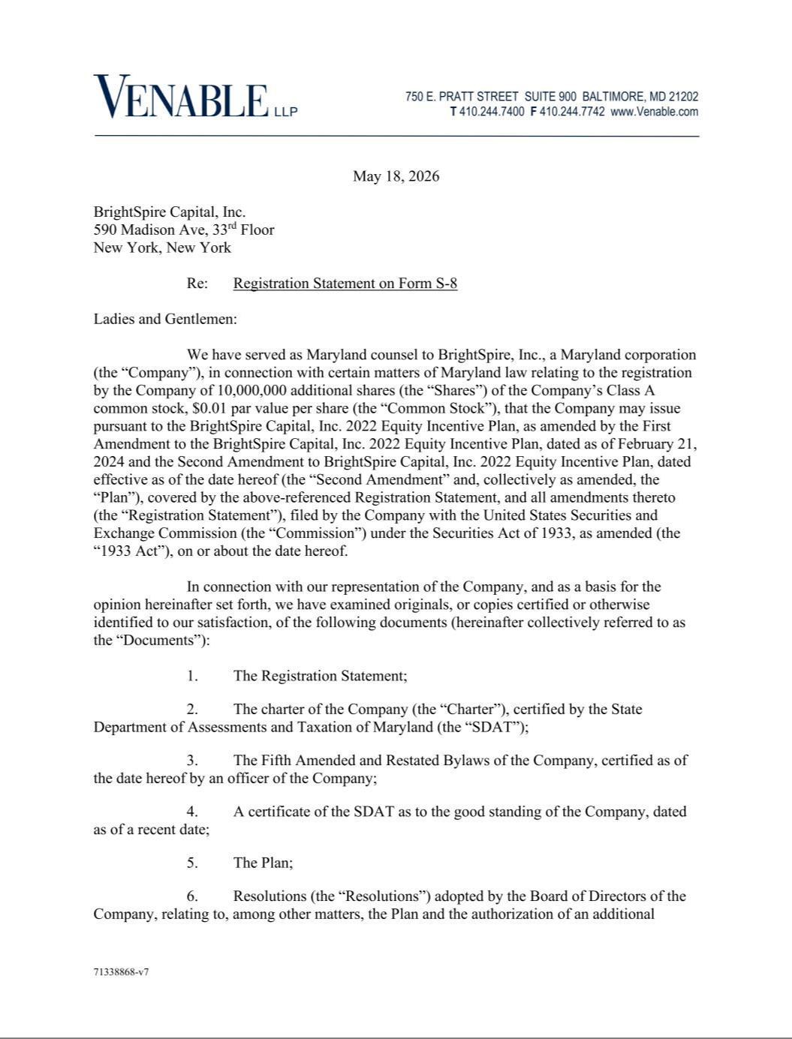

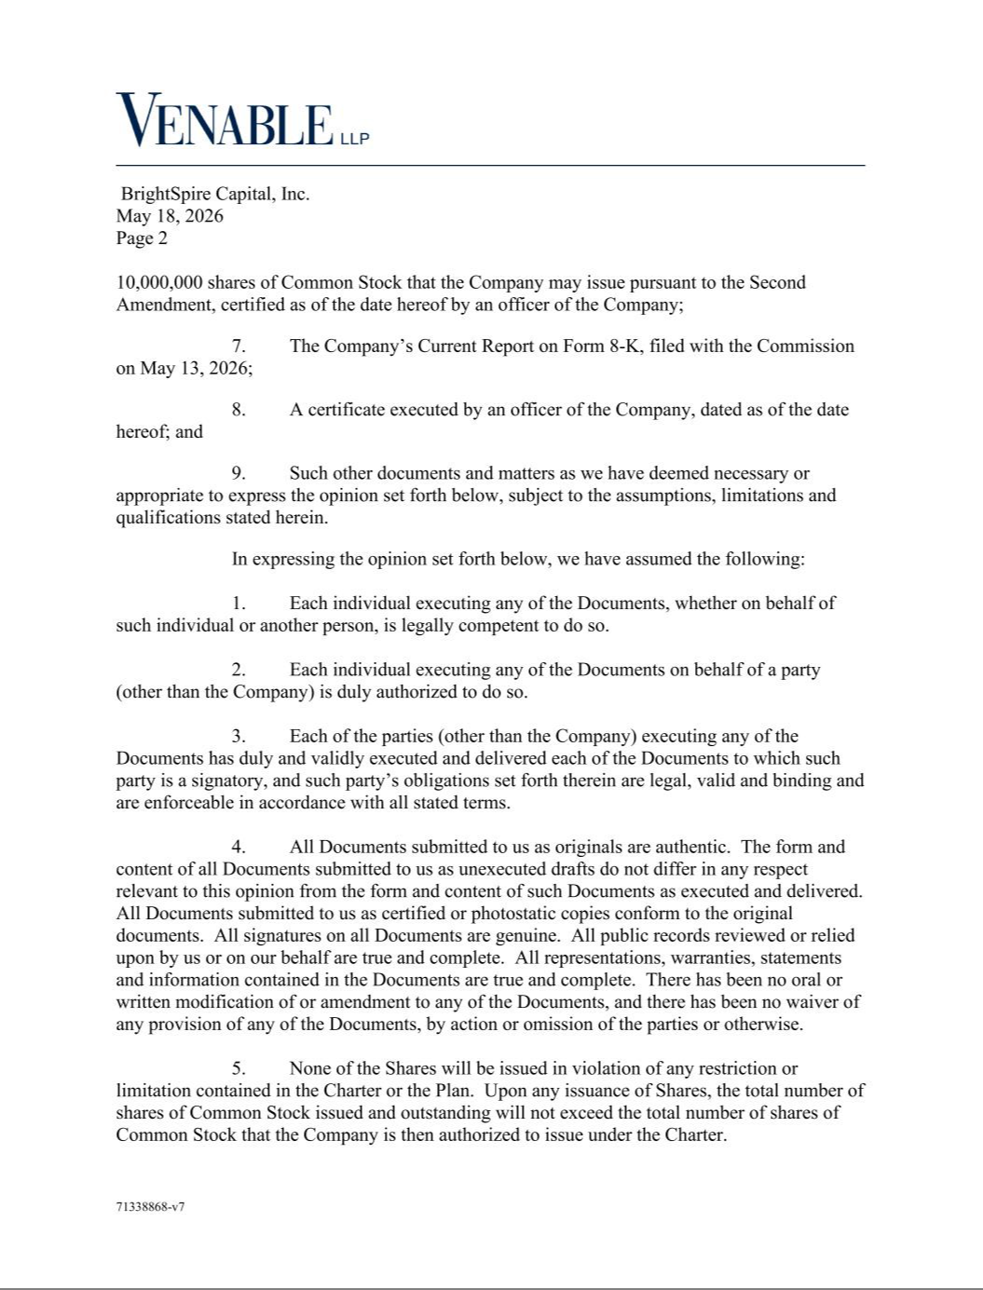

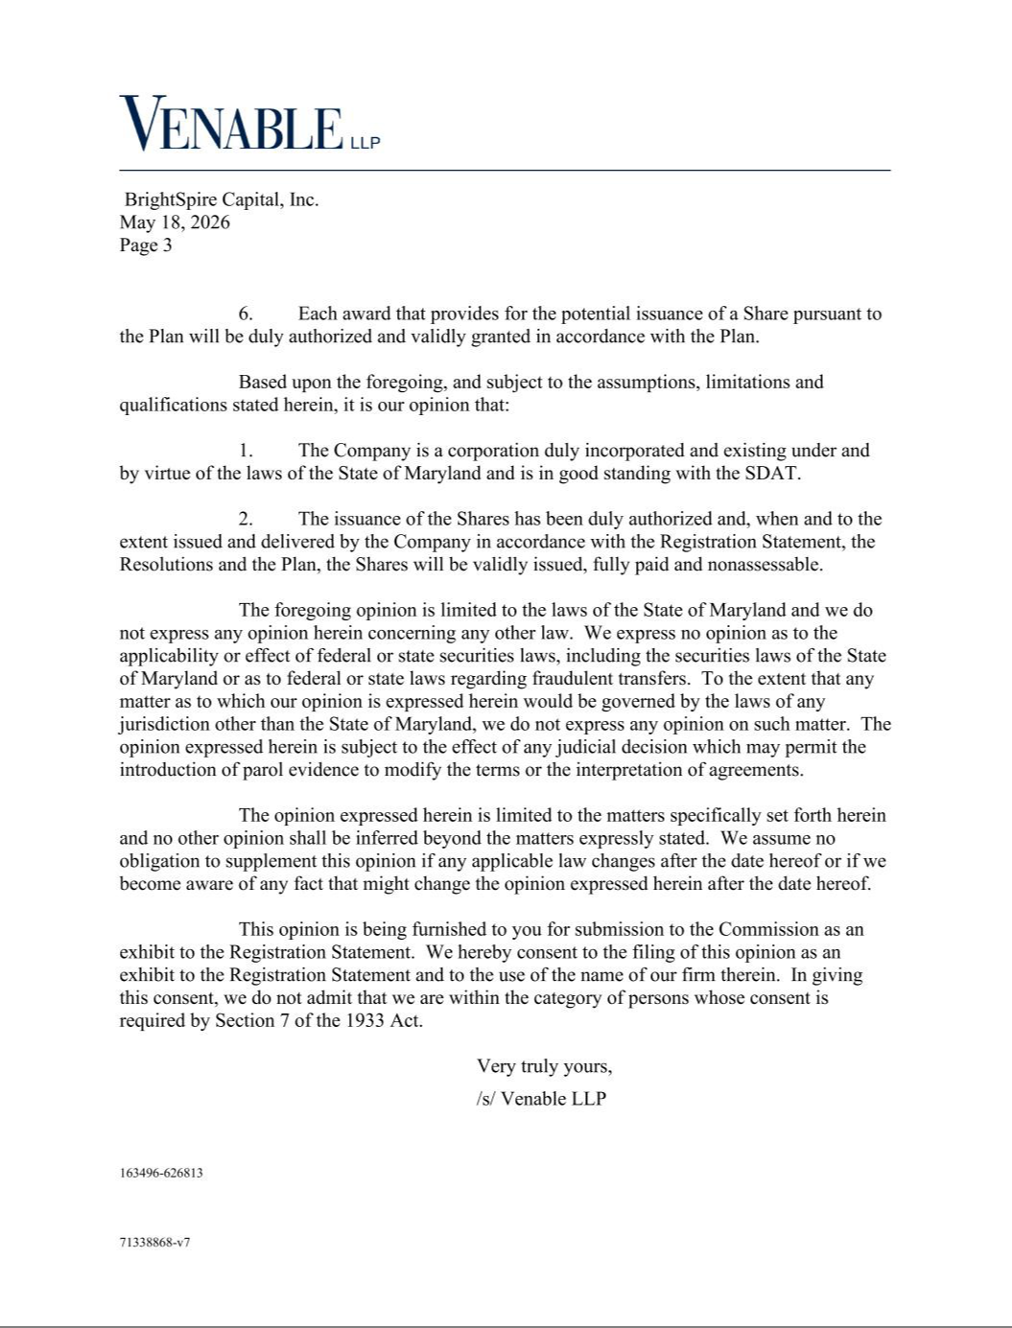

Exhibit 23.2

CONSENT OF INDEPENDENT REGISTERED PUBLIC ACCOUNTING FIRM

We consent to the incorporation by reference in this Registration Statement on Form S-8 of our reports dated February 18, 2026 relating to the financial statements of BrightSpire Capital, Inc. and the effectiveness of BrightSpire Capital, Inc’s internal control over financial reporting, appearing in the Annual Report on Form 10-K of BrightSpire Capital Inc. for the year ended December 31, 2025.

/s/ DELOITTE & TOUCHE LLP

New York, New York

May 18, 2026

Exhibit 23.3

Consent of Independent Registered Public Accounting Firm

We consent to the incorporation by reference in the Registration Statement (Form S-8) pertaining to the 2022 Equity Incentive Plan of BrightSpire Capital, Inc. of our report dated February 19, 2025, with respect to the consolidated financial statements and financial statement schedules of BrightSpire Capital, Inc., included in its Annual Report (Form 10-K) for the year ended December 31, 2025, filed with the Securities and Exchange Commission.

/s/ Ernst & Young LLP

New York, New York

May 18, 2026

